Speech-Based Analysis of Basal Ganglia and Striatal Dysfunction in Parkinson’s Disease Using Classical and Hybrid Quantum Machine Learning
________________________________________
Abstract
Parkinson’s disease (PD) is a progressive neurodegenerative disorder characterized by dopaminergic degeneration that disrupts basal ganglia motor and non-motor circuits. The striatum, as the primary input nucleus of the basal ganglia, plays a key role in motor timing, force regulation, and coordinated movement. Dysfunction of these circuits leads to characteristic speech impairments that often appear early in the disease course. This work investigates whether basal ganglia and striatal dysfunction in Parkinson’s disease can be indirectly captured through acoustic speech features and reliably identified using computational learning models. A speech-based analysis framework is developed using classical machine learning and hybrid quantum machine learning approaches. Experimental evaluation using stratified cross-validation demonstrates that speech features consistently encode disease-related neurological effects. Classical models achieve higher overall accuracy, while hybrid quantum models exhibit strong sensitivity despite current computational constraints. The results support the use of speech as a non-invasive biomarker of basal ganglia dysfunction and highlight the feasibility of both classical and quantum learning paradigms for Parkinson’s disease analysis.
Keywords: Parkinson’s disease, basal ganglia, striatum, speech analysis, classical machine learning, hybrid quantum machine learning
________________________________________
1. Introduction
Parkinson’s disease (PD) is a chronic neurodegenerative disorder affecting both motor and non-motor functions. While motor symptoms such as bradykinesia and rigidity are well recognized, speech impairment is one of the earliest and most persistent manifestations of the disease. These speech abnormalities arise primarily from degeneration of dopaminergic neurons in the substantia nigra, which disrupts basal ganglia–striatal circuitry responsible for regulating motor timing, force scaling, and movement coordination.
The striatum serves as the principal input structure of the basal ganglia, integrating cortical motor, cognitive, and emotional signals. Dopamine depletion within the striatum leads to abnormal basal ganglia output, resulting in unstable and poorly timed motor commands. Speech production, which requires fine-grained temporal coordination and precise motor control, is particularly sensitive to these disruptions. Consequently, speech signals provide a rich, non-invasive source of information for studying Parkinson’s disease–related neurological dysfunction.
Parkinson’s disease primarily affects dopaminergic signaling within the basal ganglia, with pronounced degeneration in the striatum, the principal input nucleus involved in motor timing and force regulation. Disruption of basal ganglia–thalamocortical circuits alters the initiation, coordination, and stability of motor outputs, including speech production. These impairments manifest as measurable changes in acoustic features such as pitch variability, amplitude modulation, and temporal regularity, motivating the use of speech as an indirect biomarker of underlying neural dysfunction.
Recent studies have applied machine learning techniques to speech-based Parkinson’s disease detection; however, many focus primarily on predictive performance without explicitly considering neurological interpretation. In parallel, quantum machine learning has emerged as a promising computational paradigm, though its application to neurological speech analysis remains limited. This study presents a speech-based analysis framework grounded in basal ganglia neurophysiology and evaluates both classical and hybrid quantum machine learning models for Parkinson’s disease detection.
________________________________________
2. Related Work
Speech impairment is a well-documented and early manifestation of Parkinson’s disease (PD), commonly associated with hypokinetic dysarthria. Prior clinical and acoustic studies have reported characteristic abnormalities such as reduced vocal intensity, monotonic pitch, increased jitter and shimmer, altered speech rhythm, and impaired articulatory precision. These speech deficits arise from disrupted motor control rather than peripheral vocal pathology, making speech a valuable non-invasive signal for neurological assessment.
Neurophysiological research has established that Parkinson’s disease is primarily driven by dopaminergic neuron degeneration in the substantia nigra, leading to dopamine depletion in the striatum and subsequent dysfunction of basal ganglia–cortical loops. These circuits play a central role in regulating motor timing, movement amplitude, and sensorimotor integration. While the relationship between basal ganglia dysfunction and limb motor symptoms has been extensively studied, fewer works explicitly link striatal dysfunction to quantifiable speech signal characteristics. Existing speech studies often report acoustic abnormalities without grounding them in underlying neural mechanisms.
Machine learning approaches have been widely applied to speech-based Parkinson’s disease detection, employing classifiers such as support vector machines, artificial neural networks, k-nearest neighbors, and ensemble methods. Many studies report high classification accuracy using handcrafted acoustic features or deep learning representations. However, a large portion of this literature emphasizes predictive performance while offering limited interpretability or neurophysiological justification for why specific speech features are informative. As a result, speech is frequently treated as a generic signal rather than as a reflection of impaired basal ganglia motor control.
Recent advances have sought to improve robustness and generalization through cross-validation, feature selection, and ensemble learning. Despite these improvements, most studies remain confined to classical machine learning paradigms and do not explore alternative computational frameworks that may capture different structural properties of the data. Additionally, comparative analyses across multiple modeling paradigms within a unified experimental framework are relatively scarce.
Quantum machine learning has recently emerged as a promising computational paradigm for pattern recognition and kernel-based learning, particularly in high-dimensional and structured data settings. Early biomedical applications have explored quantum-enhanced classification for small-scale datasets; however, the application of quantum or hybrid quantum–classical models to neurological speech analysis remains largely unexplored. Existing works are primarily proof-of-concept studies and rarely address clinically relevant metrics such as recall or provide physiological interpretation of model behavior.
In summary, while prior research has demonstrated the feasibility of speech-based Parkinson’s disease detection, several gaps remain. First, there is limited integration of speech signal analysis with basal ganglia and striatal neurophysiology. Second, most studies prioritize accuracy over interpretability and clinical relevance. Third, the potential role of emerging hybrid quantum machine learning approaches in neurological speech analysis has not been systematically investigated. The present study addresses these gaps by developing a neurologically grounded speech-based analysis framework and conducting a comparative evaluation of classical and hybrid quantum machine learning models under a unified and reproducible experimental setting.
________________________________________
3. Methodology
3.1 Data and Features
Speech recordings were represented using a high-dimensional set of acoustic and temporal features extracted from sustained phonation tasks. The feature set includes measures of vocal fold vibration stability (jitter), amplitude variability (shimmer), nonlinear dynamics, pulse timing, and spectral characteristics. These features were selected due to their sensitivity to motor timing irregularities, force instability, and expressive deficits associated with basal ganglia and striatal dysfunction.
A reduced subset of the data was used for hybrid quantum experiments to ensure computational feasibility under current quantum simulation constraints.
Figure 1. Class distribution of the Parkinson’s disease speech dataset, illustrating the proportion of healthy controls and Parkinson’s disease subjects. Stratified sampling was employed during training and cross-validation to mitigate the effects of class imbalance.
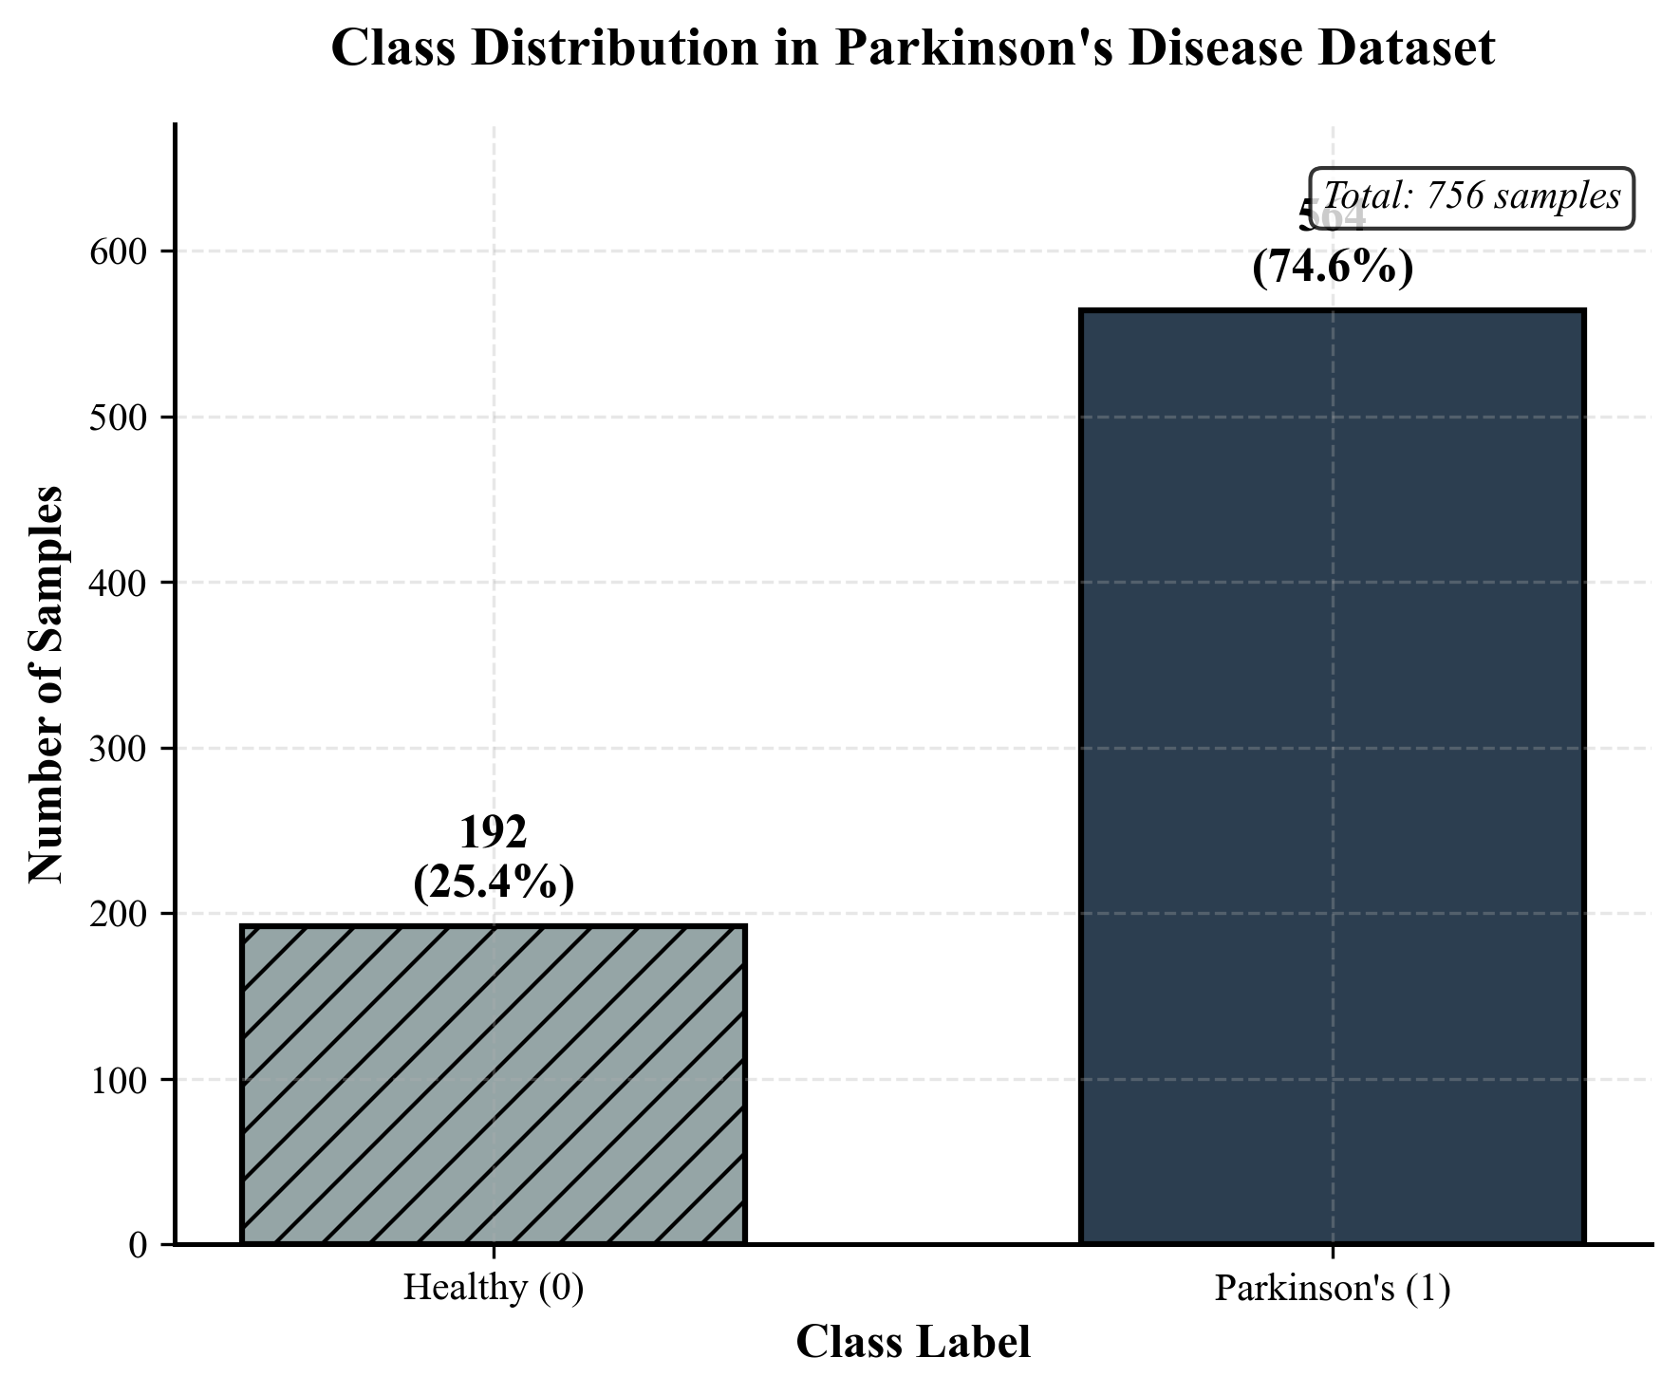
________________________________________
3.2 Preprocessing
All features were converted to numerical form, and missing values were handled using median imputation. Feature scaling was applied where required. To address class imbalance, stratified sampling was employed during train–test splitting and cross-validation.
________________________________________
3.3 Classical Machine Learning Models
Three classical classifiers were evaluated: Logistic Regression, Support Vector Machine with a radial basis function kernel, and XGBoost. These models were trained using the full feature space to capture both linear and nonlinear relationships between speech features and disease status. Pipeline-based preprocessing ensured consistent feature scaling and model training.
________________________________________
3.4 Hybrid Quantum Machine Learning Models
To investigate the feasibility of quantum-enhanced learning for Parkinson’s disease speech analysis, hybrid quantum machine learning models were evaluated alongside classical approaches. These models combine classical preprocessing with quantum computational components and are designed to operate under the constraints of current quantum hardware and simulation environments.
Due to the direct relationship between feature dimensionality and the number of required qubits, dimensionality reduction was applied prior to quantum model training. Principal Component Analysis (PCA) was used to project the original high-dimensional speech feature space onto a low-dimensional subspace while preserving the most informative variance. This step is essential for ensuring computational feasibility, as current quantum simulators and near-term quantum devices are limited in the number of qubits and circuit depth they can reliably support.
Following dimensionality reduction, features were rescaled and encoded into quantum circuits using angle encoding. In this encoding scheme, each feature value is mapped to a rotation angle of a quantum gate, allowing continuous-valued speech features to be embedded into quantum states. Angle encoding was selected due to its simplicity, low circuit complexity, and compatibility with noisy intermediate-scale quantum (NISQ) devices.
Two hybrid quantum models were evaluated. The first model is a Quantum Support Vector Machine (QSVM) employing a fidelity-based quantum kernel. In this approach, a parameterized quantum feature map transforms classical input data into a quantum Hilbert space, where similarity between samples is computed via quantum state fidelity. This kernel-based formulation enables the model to capture global feature relationships that may be difficult to represent in classical feature spaces.
The second model is a Variational Quantum Classifier (VQC), which utilizes a parameterized quantum circuit composed of trainable rotation and entanglement gates. Model training is performed using a classical optimizer that updates circuit parameters to minimize classification error, forming a hybrid quantum–classical optimization loop. This approach allows the model to learn task-specific representations while maintaining compatibility with limited quantum resources.
All quantum experiments were executed using a quantum simulator backend to ensure reproducibility and experimental control. The hybrid nature of the models reflects current best practices in quantum machine learning, where classical preprocessing and optimization are combined with quantum representations rather than relying on fully quantum pipelines.
This design enables a fair and realistic assessment of quantum learning paradigms for neurological speech analysis, while acknowledging the practical limitations of current quantum technologies.
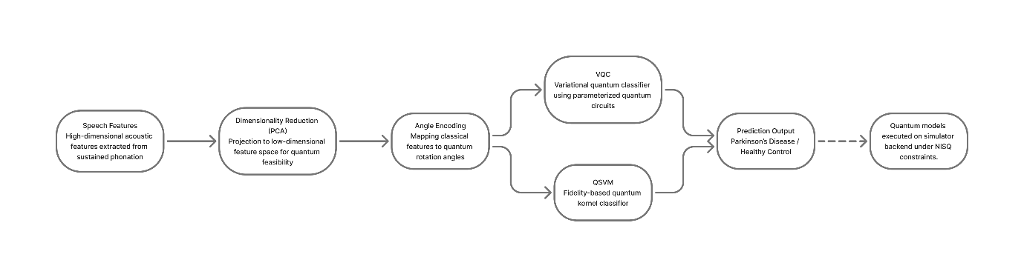
Figure X. Overview of the hybrid quantum machine learning workflow, illustrating dimensionality reduction, angle encoding of speech features, and classification using quantum kernel and variational quantum circuit models executed on a simulator backend.
________________________________________
3.5 Evaluation Strategy
Model performance was evaluated using stratified 10-fold cross-validation. Accuracy, recall, F1-score, and area under the ROC curve were used as evaluation metrics. Recall was emphasized due to its clinical relevance in minimizing false negatives for Parkinson’s disease detection.
________________________________________
4. Results and Discussion

4.1 Classical Machine Learning Model Performance Analysis
Classical machine learning models demonstrate strong capability in identifying Parkinson’s disease–related speech abnormalities, indicating that acoustic features reliably encode neurological effects associated with basal ganglia and striatal dysfunction. Across all evaluated metrics, the classical models achieve consistently high performance, with ensemble-based approaches yielding the most favorable results.
Among the evaluated models, XGBoost attains the highest overall accuracy and area under the ROC curve, suggesting superior discrimination between healthy controls and Parkinson’s disease subjects. This performance advantage can be attributed to the model’s ability to capture nonlinear relationships and higher-order interactions among speech features. Speech production is governed by complex motor control mechanisms involving timing precision, force modulation, and feedback regulation—processes that are disrupted in Parkinson’s disease due to dopaminergic depletion within the striatum. The nonlinear modeling capacity of ensemble methods aligns well with these heterogeneous and nonstationary speech impairments.
Support Vector Machines and Logistic Regression also demonstrate strong recall, indicating reliable detection of Parkinson’s disease cases. High recall is clinically significant, as it minimizes false negatives and supports early disease identification. The comparatively lower accuracy of linear models reflects the limited ability of linear decision boundaries to fully capture the complex dynamics present in speech signals affected by basal ganglia dysfunction. Nevertheless, their stable performance confirms that disease-related speech alterations are consistently present across the dataset.
Receiver operating characteristic analysis further highlights the robustness of classical models, with all classifiers achieving ROC-AUC values substantially above chance level. This confirms that speech features provide meaningful separation between classes and that basal ganglia–related motor deficits manifest in measurable acoustic patterns. Additionally, cross-validation results demonstrate low variance across folds, indicating that model performance is stable and not driven by data partitioning artifacts.
Overall, the classical machine learning results establish a strong performance baseline and confirm that speech-based acoustic features serve as reliable biomarkers of Parkinson’s disease. These findings provide a necessary reference point for evaluating hybrid quantum models and support the broader hypothesis that basal ganglia and striatal dysfunction can be indirectly assessed through computational analysis of speech.
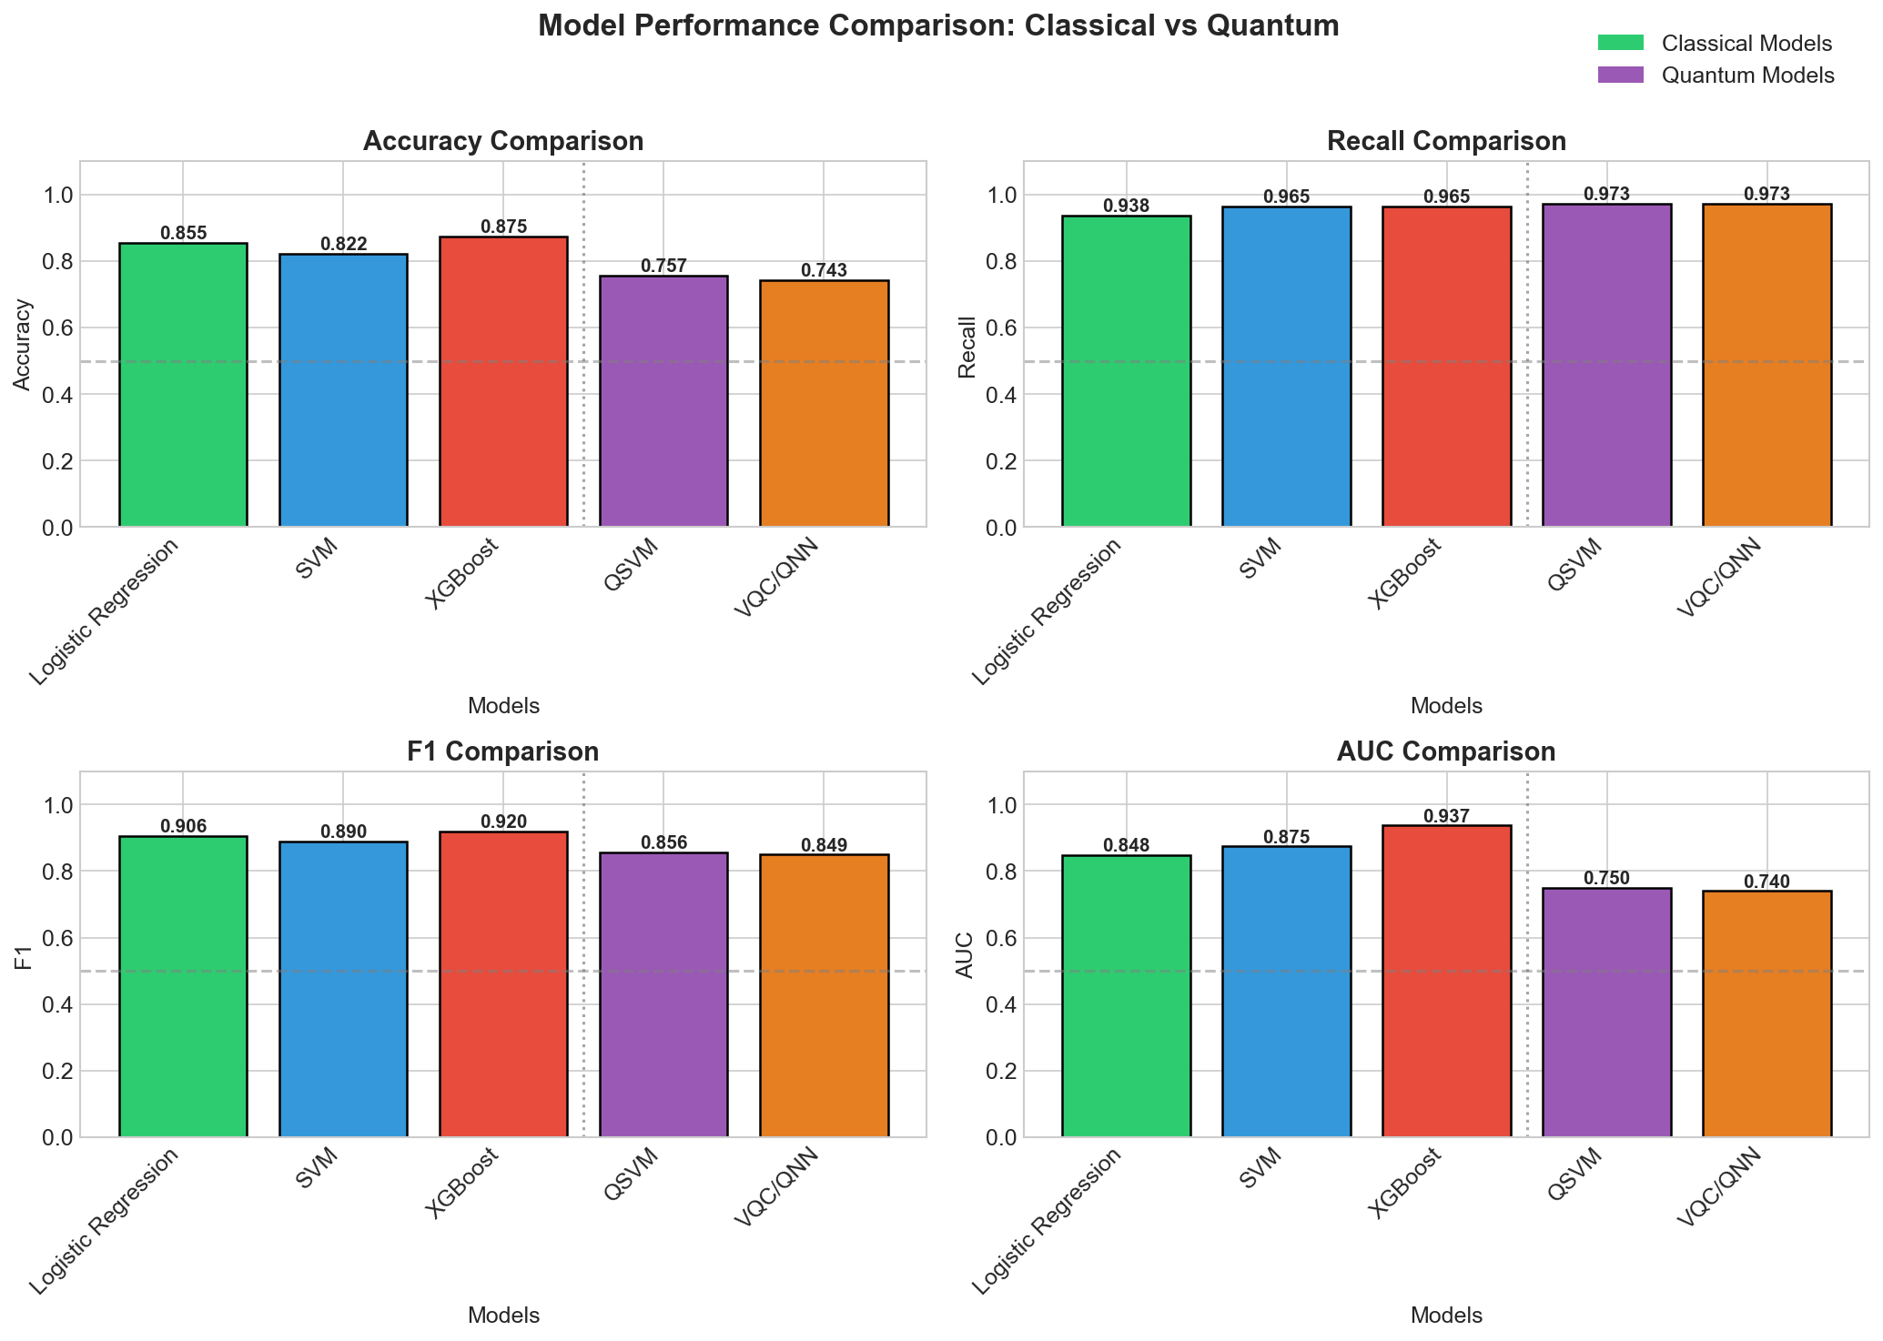
Figure 2. Comparative performance of classical machine learning models and hybrid quantum machine learning models evaluated using accuracy, recall, F1-score, and AUC. Classical models achieve higher overall accuracy and discriminative power, while hybrid quantum models demonstrate competitive recall under reduced feature dimensionality constraints.
4.2 Hybrid Quantum Machine Learning Model Performance and Sensitivity
Hybrid quantum machine learning models demonstrate distinct performance characteristics compared to their classical counterparts, reflecting both their computational constraints and their sensitivity to Parkinson’s disease–related speech abnormalities. Although quantum models achieve lower overall accuracy, their consistently high recall indicates strong sensitivity in detecting pathological speech patterns associated with basal ganglia and striatal dysfunction.
Both the Quantum Support Vector Machine (QSVM) and the Variational Quantum Classifier (VQC) exhibit recall values comparable to those of the best-performing classical models. This observation is clinically significant, as high recall minimizes false negatives and supports early identification of Parkinson’s disease. The preservation of sensitivity despite aggressive dimensionality reduction suggests that disease-relevant information is concentrated within a low-dimensional subspace of the original speech feature space. This aligns with the hypothesis that basal ganglia dysfunction produces systematic and structured motor timing abnormalities that remain detectable even under constrained feature representations.
The reduced accuracy and F1-scores observed in quantum models can be attributed primarily to current technological limitations rather than a lack of discriminative information in speech features. Hybrid quantum models operate under strict constraints on feature dimensionality, circuit depth, and optimization stability when executed on quantum simulators. As a result, these models are less capable of capturing subtle class boundary refinements that contribute to higher specificity. This trade-off manifests as reduced precision while maintaining high sensitivity.
Notably, the performance behavior of hybrid quantum models differs qualitatively from that of classical models. While classical ensemble methods leverage extensive feature interactions to maximize discrimination, quantum models emphasize global feature relationships through kernel-based similarity measures and parameterized quantum circuits. This difference suggests that quantum learning paradigms may be inherently well-suited for capturing coarse-grained disease signatures rather than fine-grained class separation under current hardware constraints.
Overall, the hybrid quantum results demonstrate that Parkinson’s disease–related speech abnormalities remain detectable within quantum learning frameworks, even when operating under limited representational capacity. These findings highlight the feasibility of quantum-enhanced learning for neurological speech analysis and suggest that future advances in quantum hardware, circuit optimization, and noise mitigation may further improve specificity and overall performance. Importantly, the observed sensitivity supports the potential role of hybrid quantum models as complementary tools for early disease screening rather than replacements for classical approaches.
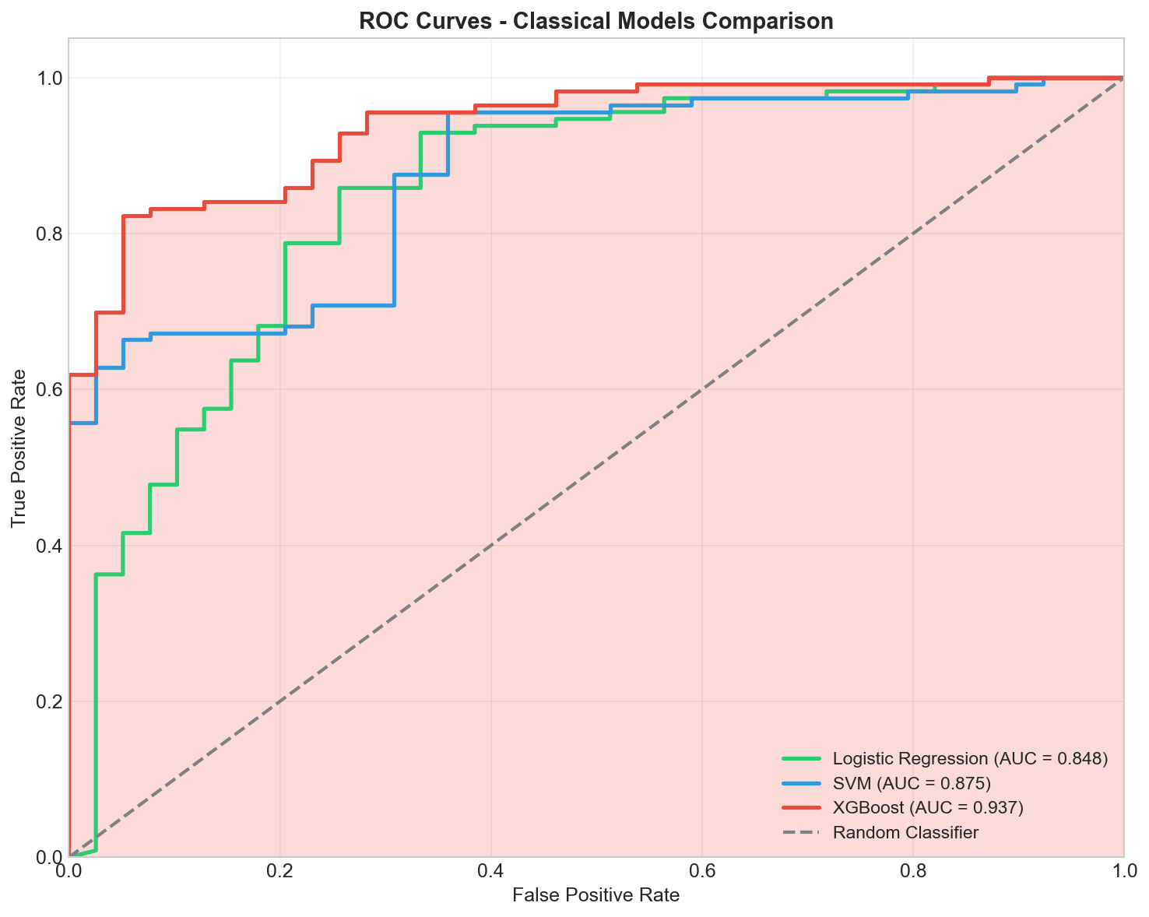
Figure 3. Performance of hybrid quantum machine learning models, including Quantum Support Vector Machine (QSVM) and Variational Quantum Classifier (VQC), evaluated using accuracy, recall, and F1-score. Despite reduced feature dimensionality and circuit constraints, quantum models maintain high recall, indicating strong sensitivity to Parkinson’s disease–related speech abnormalities.
4.3 Cross-Validation Stability and Generalization Analysis
To assess the robustness and generalization capability of the proposed models, performance was evaluated using stratified 10-fold cross-validation. Across all classical models, evaluation metrics exhibit low variability between folds, indicating stable learning behavior and consistent detection of Parkinson’s disease–related speech abnormalities.
The observed stability suggests that model performance is not driven by favorable data partitions or sampling artifacts. Instead, the consistency across folds confirms that disease-relevant speech features are systematically encoded within the dataset. This is particularly important in neurological applications, where inter-subject variability and recording conditions can introduce significant noise.
Classical ensemble models demonstrate the lowest variance, reflecting their ability to aggregate multiple decision boundaries and mitigate sensitivity to individual feature fluctuations. Linear and margin-based classifiers also show stable recall across folds, further reinforcing the reliability of speech-based Parkinson’s disease detection.
Overall, the cross-validation results support the generalizability of the proposed framework and confirm that the reported performance reflects genuine disease-related patterns rather than overfitting. This robustness is essential for potential clinical translation, where consistent performance across diverse patient populations is required.
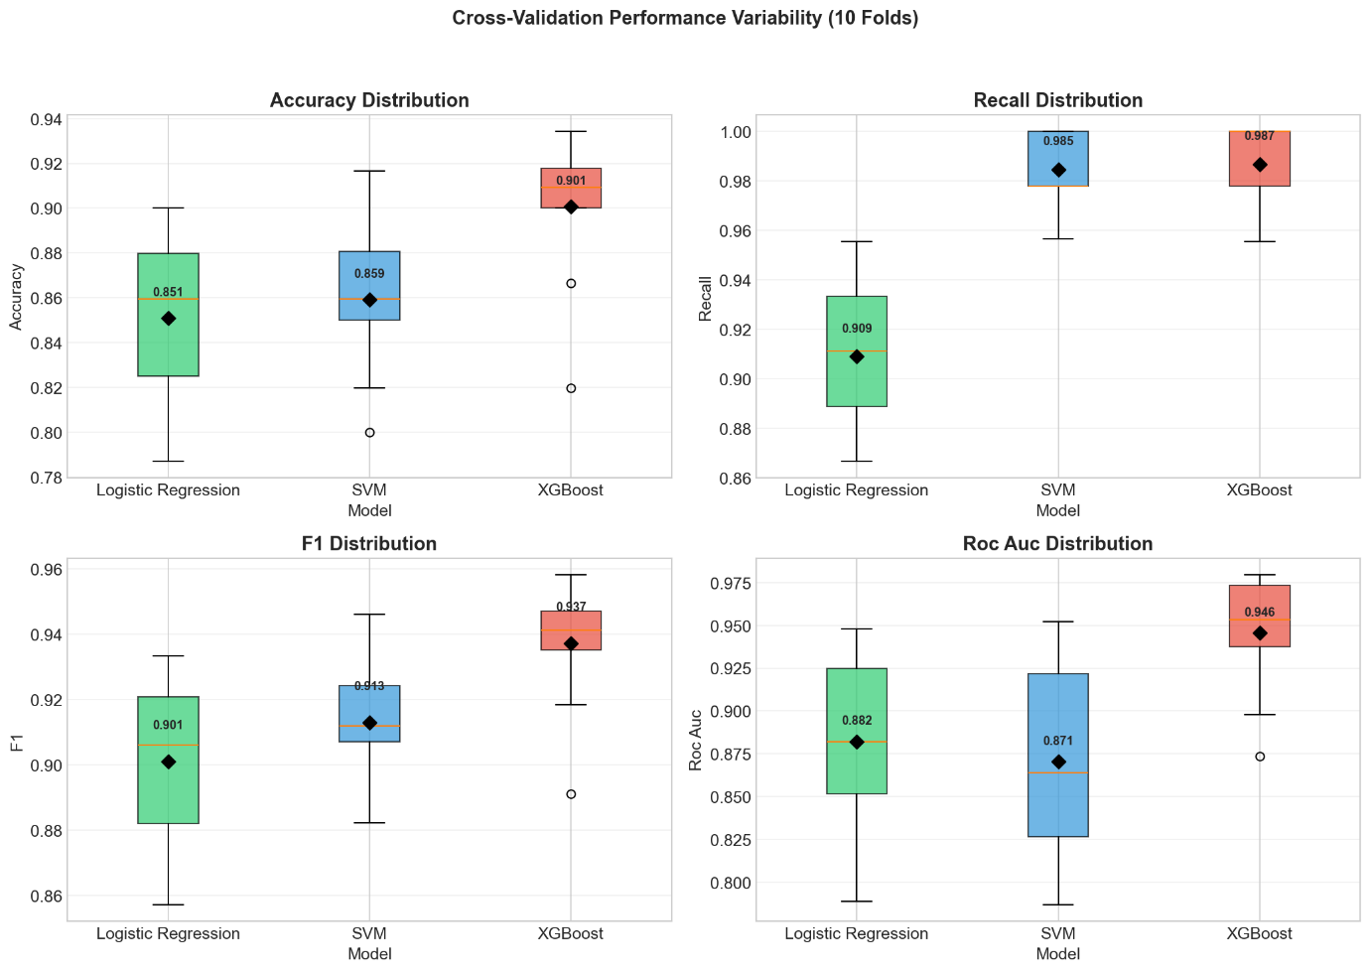
Figure 4. Distribution of accuracy, recall, F1-score, and ROC-AUC across 10-fold stratified cross-validation for classical machine learning models. The narrow interquartile ranges indicate stable performance and robust generalization across folds.

4.4 Feature-Level Neurological Interpretation of Speech Abnormalities
Analysis of feature importance reveals that the most discriminative speech features primarily relate to vocal instability, temporal irregularity, and nonlinear dynamics. These feature groups are closely associated with impaired motor timing and force regulation, which are hallmark consequences of basal ganglia and striatal dysfunction in Parkinson’s disease.
Measures of frequency perturbation, such as jitter-related features, emerge as dominant contributors across models. Jitter reflects cycle-to-cycle variability in vocal fold vibration and is sensitive to disruptions in fine motor timing. In Parkinson’s disease, dopamine depletion within the striatum leads to abnormal basal ganglia output, resulting in increased neural noise and reduced precision of motor commands. This manifests acoustically as unstable phonation, directly captured by elevated jitter measures.
Amplitude-based features, including shimmer and related energy variability metrics, also exhibit high importance. These features reflect impaired force scaling and reduced control over respiratory and laryngeal musculature. The basal ganglia play a critical role in regulating movement amplitude, and dysfunction within striatal pathways leads to hypometric motor output. In speech production, this presents as reduced vocal intensity and amplitude instability, consistent with hypokinetic dysarthria.
Nonlinear dynamic features and entropy-based measures further contribute to class discrimination. These features capture irregularities in speech signal structure and complexity, reflecting disrupted sensorimotor feedback and impaired coordination across speech subsystems. Such abnormalities align with the role of basal ganglia circuits in integrating cortical motor plans with real-time feedback. Increased signal irregularity therefore represents a downstream acoustic signature of dysfunctional basal ganglia–cortical loops.
Collectively, the feature-level analysis provides neurophysiological grounding for the observed model performance. Rather than relying on abstract statistical patterns, the models leverage speech characteristics that directly reflect known motor control deficits associated with Parkinson’s disease. This supports the use of speech as a non-invasive biomarker of basal ganglia and striatal dysfunction and reinforces the interpretability of the proposed computational framework.
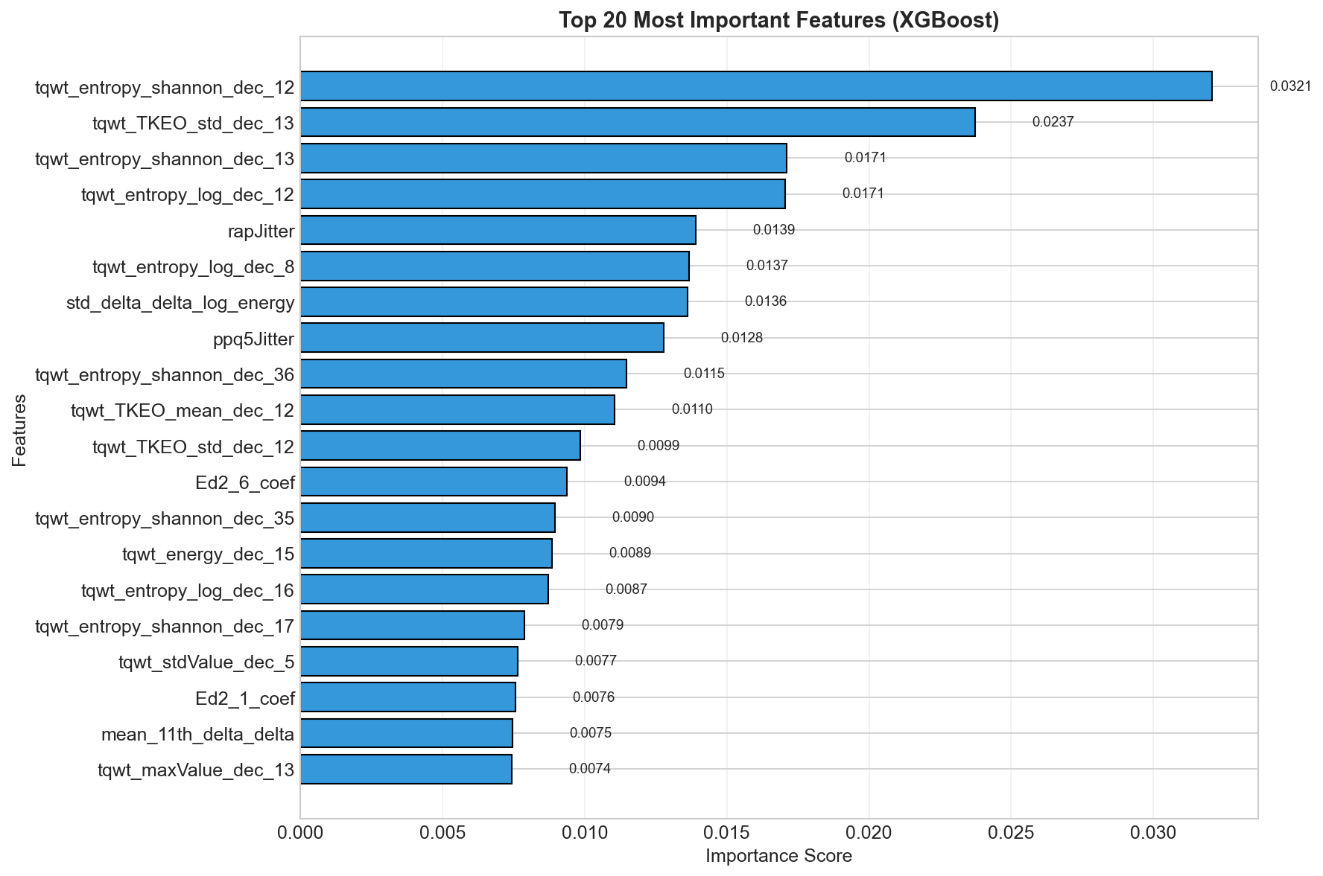

Figure 5. Relative importance of top-ranked speech features identified by the ensemble-based model. Dominant features correspond to vocal instability, amplitude variability, and nonlinear dynamics, reflecting impaired motor timing, force regulation, and sensorimotor integration associated with basal ganglia and striatal dysfunction in Parkinson’s disease.

________________________________________
5. Conclusion
This study demonstrates that basal ganglia and striatal dysfunction in Parkinson’s disease produces measurable speech abnormalities that can be effectively captured using acoustic features. A neurologically grounded speech-based analysis framework was developed and evaluated using both classical and hybrid quantum machine learning models. While classical models achieve superior overall performance, hybrid quantum models exhibit strong sensitivity despite current computational constraints. These findings support the use of speech as a non-invasive biomarker for Parkinson’s disease and highlight the potential of quantum-enhanced learning approaches as quantum technologies continue to mature.

